
QUESTION PAPER | : | LAB ASSIGNMENT-8 | SHEET : 1 OF 1
COURSE TITLE | : | JAVA | BATCH NO :
MODULE | : | Applet | MARKS :
TIME | : | 1:00 hr | DATE :

Q.1  Q.2  Q.3  Q.4  Q.5  Q.6 | 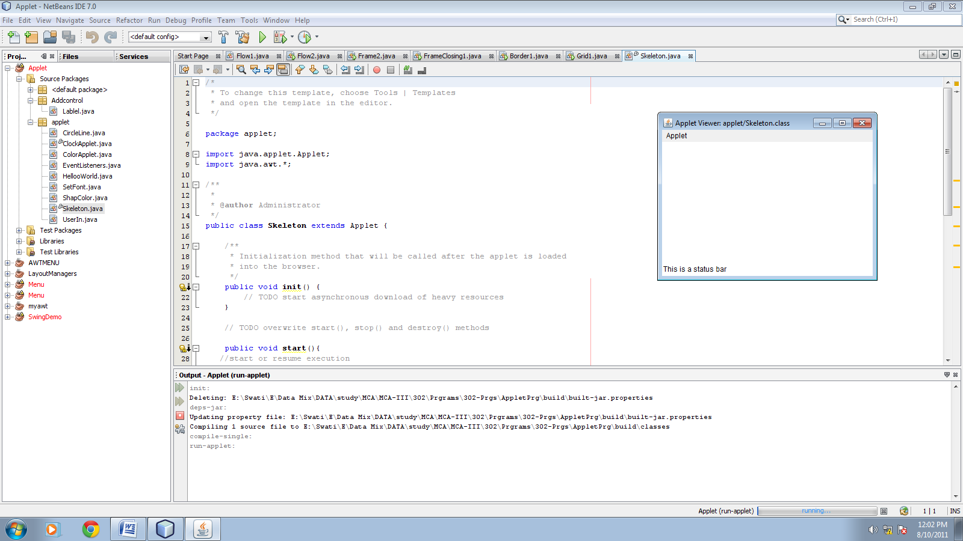  Write a Java program to create a skeleton of an applet.  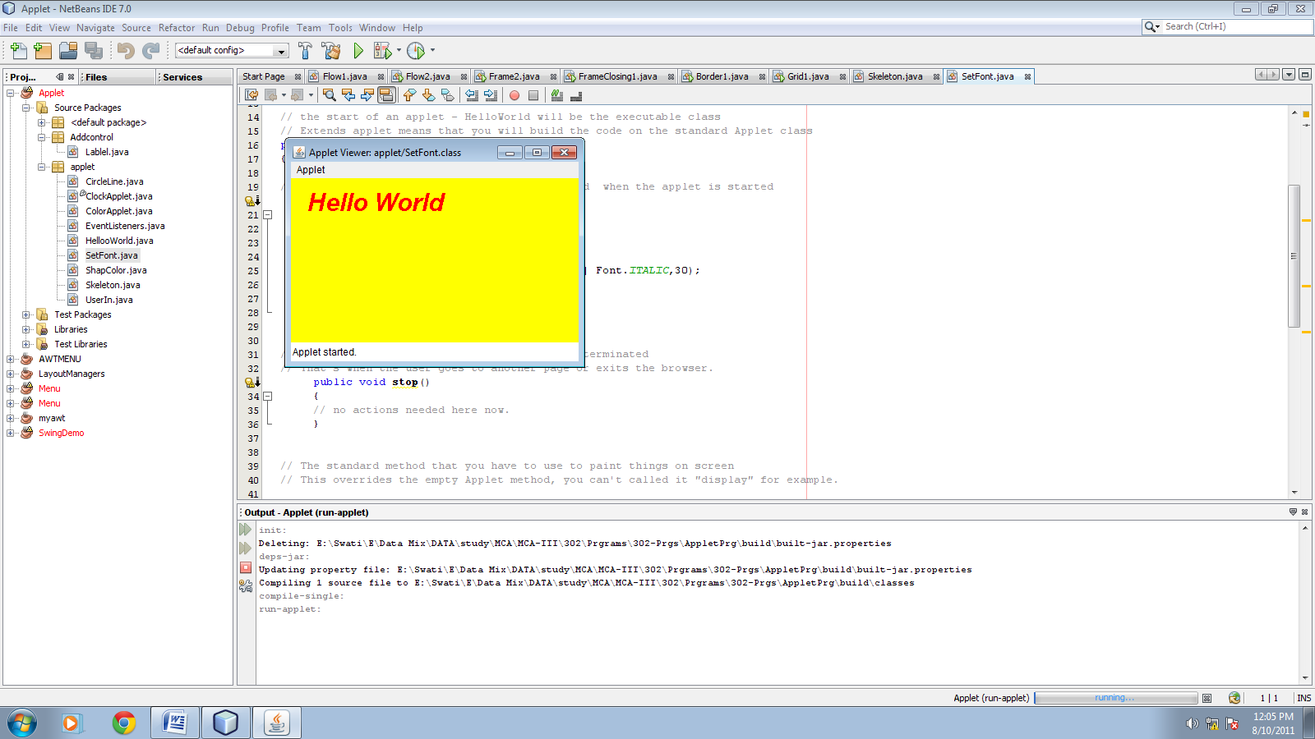  Write a Java program to create an applet window. Set backgrond color as yellow. Draw a string “Hello World” onto the applet window at position (40,60). Set the font color as red, type as “Arial” and size is 30.  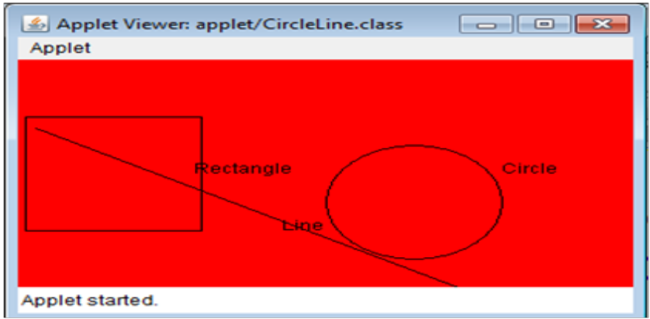  Write a Java program to create an applet window. Set backgrond color as red. Draw number of shapes as per give demo above with its lable at specific position.  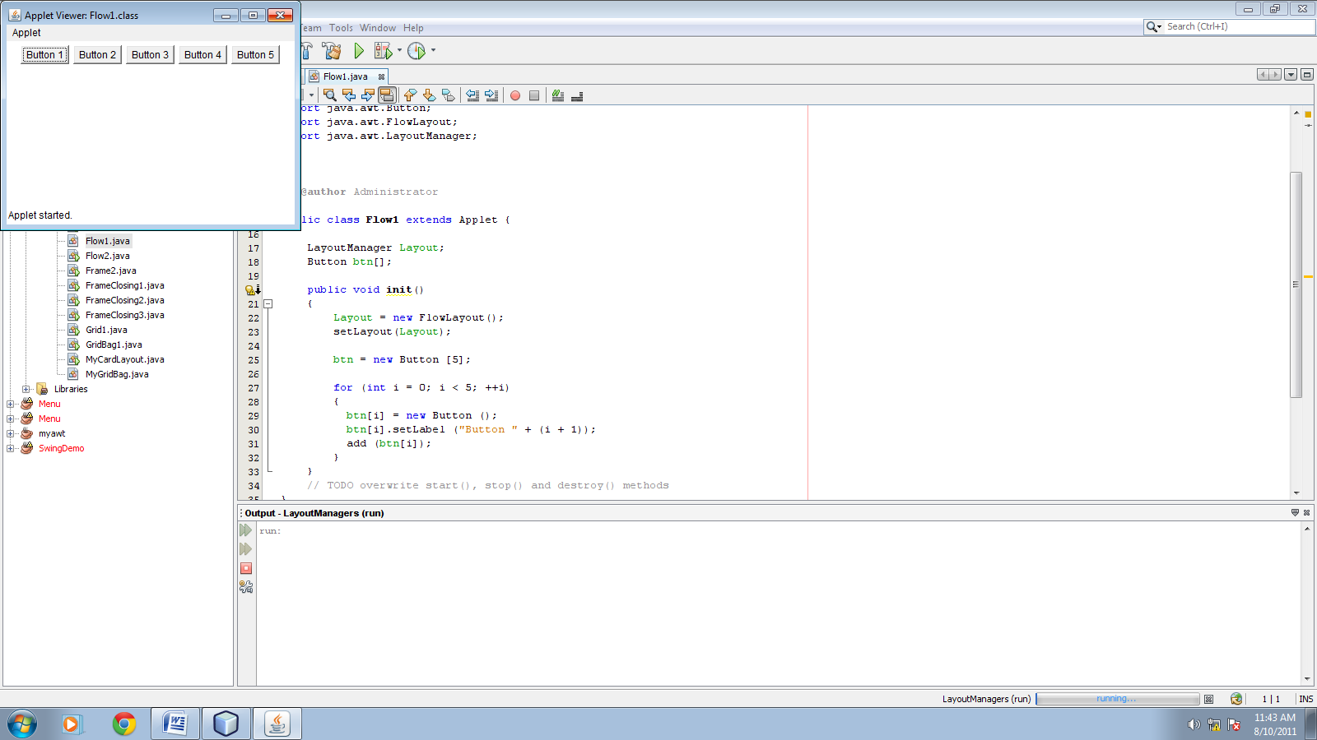  Using AWT package, write a Java program to create an applet window. Add number of buttons onto the applet window as per given demo above. Use flowlauout manager to positioning the buttons. Give horizontal gap as 20 and vertical gap as 30 between the controls.  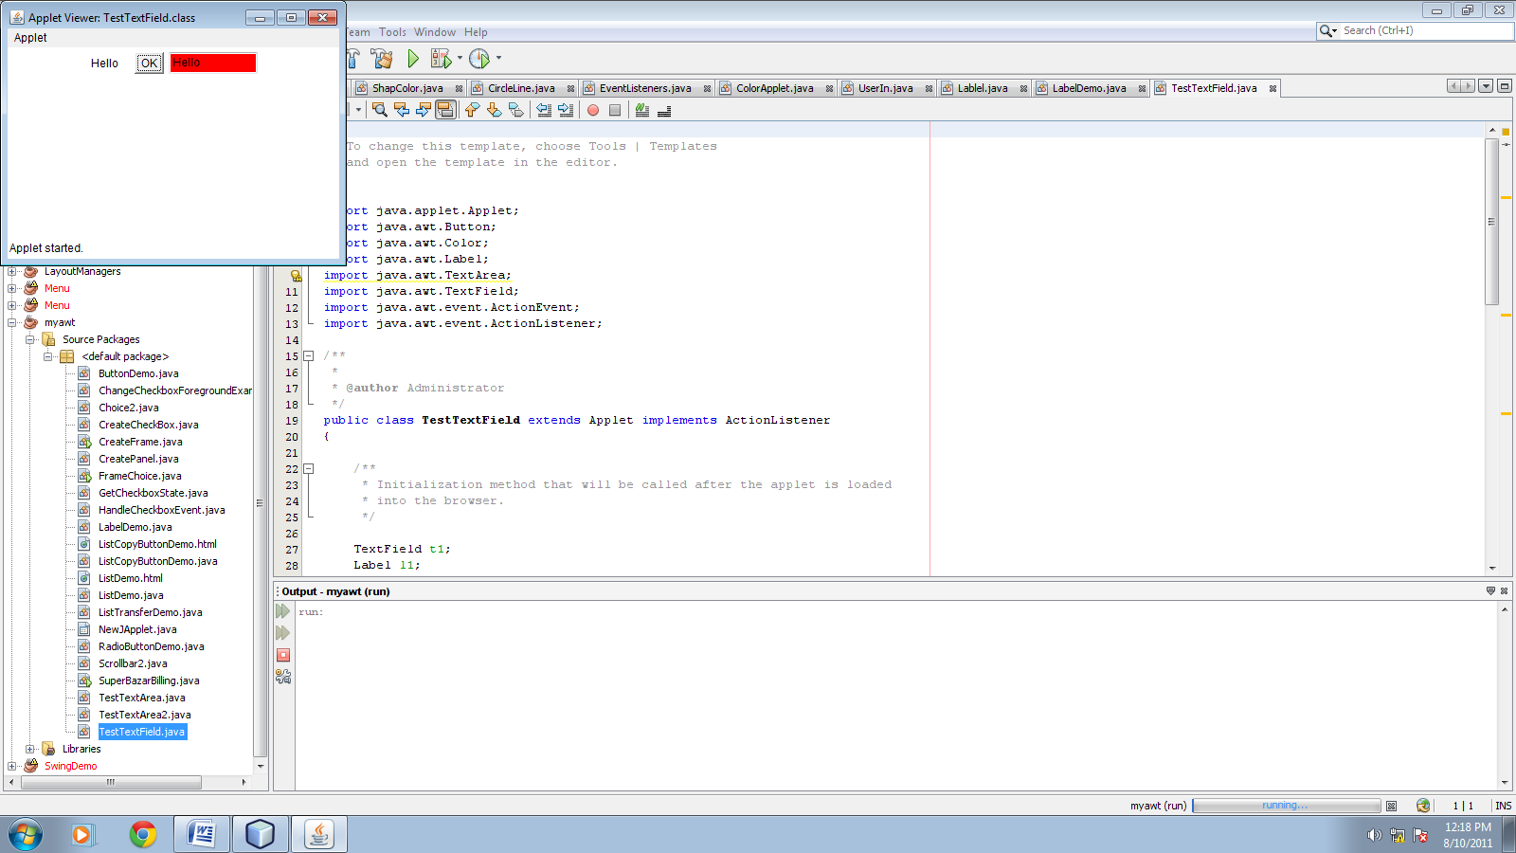  Uisng AWT package, write a Java program to create an applet window. Add Label control named as lbl1 and labeled as “Hello” , Button control named as btn1 and labeled as “OK” and TextField named as tf1 onto the applet window as per given demo above. By clicking on the “OK” button, label of Label control is display onto the TextField control. Use flowlauout manager to positioning the buttons. Give horizontal gap as 20 and vertical gap as 30 between the controls.  Write An Applet Program To Do Calculation Based On Selected Operator From Choice Using ActionListener.  